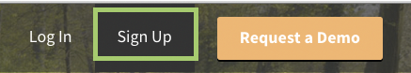
Directions for setting up a Parent Account in Schoology

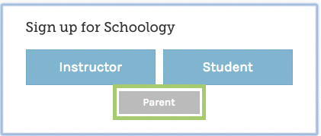
In your browser, navigate to app.schoology.com.
In the top right corner of the screen, click Sign Up
Click Parent
You should have received a Parent Access Code from your child’s school. Enter that code here:
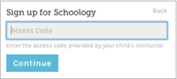
5. Enter your name, email address, and password
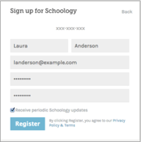

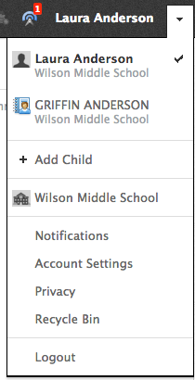

.
Once you log in, you’ll be able to browse your child’s activities by selecting your child’s
name from the top right dropdown.

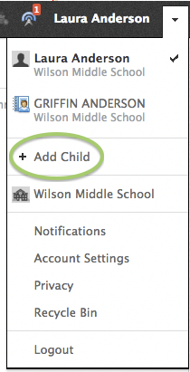
You also have the option to associate additional children using Schoology with this account. To associate additional children, click on the downfacing arrow on the top right of your Schoology account, select Add Child, and enter the Parent Access Code for your other child/children.

